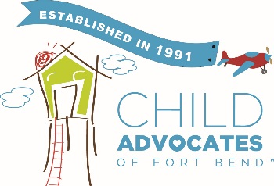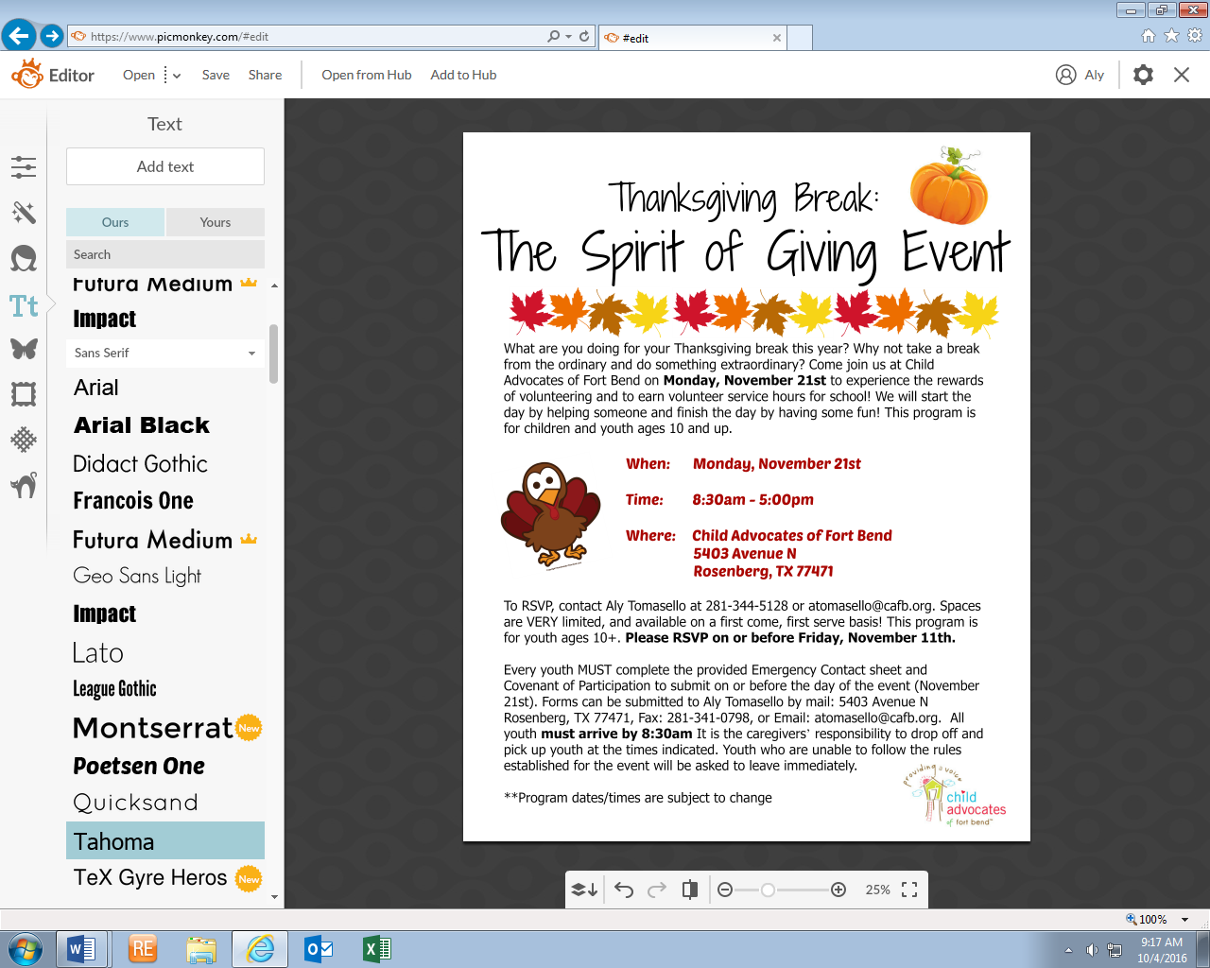

**When: Tuesday, November 24, 2020**

**Time: 8:30am-5:00pm**

*End time subject to change, please check with staff on day-of)

**Where: CAFB Children’s Advocacy Center**

**6415 Reading Road Rosenberg, TX 77471**

**Rosenberg, TX 77471**

Spaces are VERY limited, and available on a first-come, first-serve basis! Please RSVP and submit enclosed forms to Krystal Vann (at [khughes@cafb.org](mailto:khughes@cafb.org) or 281-344-5130) by **Friday, November 18, 2020.**

Every youth **MUST complete the provided Emergency Contact Sheet and Covenant of Participation to submit on or before the day of the event**. Forms can be submitted to Krystal Vann by Mail: P. O. Box 8, Richmond, TX 77406, Fax: 281-341-0798, or Email: [khughes@cafb.org](mailto:khughes@cafb.org)

**All youth must arrive by 8:30am.** It is the caregivers’ responsibility to drop off and pick up youth at the times indicated. Youth who are unable to follow the rules established for the event will be asked to leave immediately.

What are you doing for your Thanksgiving Break this year? Why not take a break from the ordinary and do something extraordinary? Come join us at Child Advocates of Fort Bend on **Tuesday, November 24, 2020** to experience the rewards of volunteering and to earn volunteer service hours for school! We will start the day by volunteering, have lunch, and finish the day by having some fun! This program is for children and youth ages 6 and up.

20th).

**Please RSVP on or before Friday, November 10th.**

6-18+.