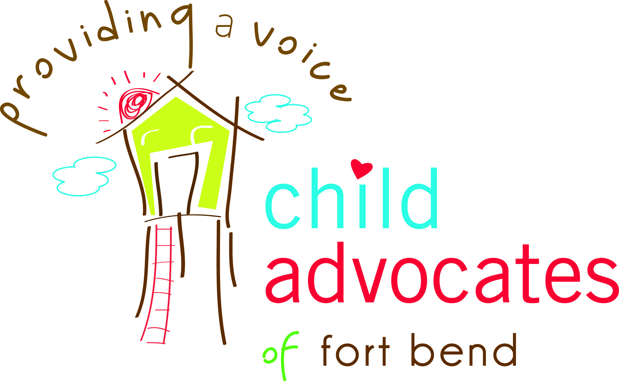
FT. BEND COUNTY CHILD ADVOCATES, INC.
CONFLICT OF INTEREST DISCLOSURE
POLICY AND PROCEDURES
UPDATED JANUARY 2017
It is in the best interest of Ft. Bend County Child Advocates, Inc., a Texas nonprofit corporation, doing business as Child Advocates of Fort Bend (“CAFB”) to be aware of and properly manage all conflicts of interest and appearances of a conflict of interest. This Conflict of Interest policy is designed to help directors, officers, employees of and other persons with an interest in CAFB identify situations that present potential conflicts of interest and to provide CAFB with a procedure to appropriately manage conflicts in accordance with legal requirements and the goals of accountability and transparency in CAFB’s operations.
- Conflict of Interest Defined. For purposes of this Policy, the following circumstances shall be deemed to create a Conflict of Interest:
- An Interested Person or a Family Member is a party to a contract, or involved in a transaction with CAFB for goods or services.
- An Interested Person or a Family Member has a material financial interest in a transaction between CAFB and an entity in which, the Interested Person or Family Member, is a director, officer, agent, partner, associate, employee, trustee, personal representative, receiver, guardian, custodian, or other legal representative.
- An Interested Person or a Family Member is engaged in some capacity or has a material financial interest in a business or enterprise that competes with CAFB.
Other situations may create the appearance of a conflict, or present a duality of interests in connection with a person who has influence over the activities or finances of CAFB. All such circumstances should be disclosed to the board or staff, as appropriate, and a decision made as to what course of action the organization or individuals should take so that the best interests of CAFB are not compromised by the personal interests of stakeholders in CAFB.
- Definitions.
- A “Conflict of Interest” is any circumstance described in Part 1 of this Policy.
- An “Interested Person” is any person serving as a director, officer, employee or representative of CAFB, or a major donor to CAFB, or anyone else who is in a position of control over CAFB or its assets who has a personal interest that is in conflict with the interests of CAFB.
- A “Family Member” is a person within the second degree of affinity or consanguinity of an Interested Person, for example, a spouse, child, parent, brother, sister, or the spouse of a child, parent, brother, or sister.
- A “Material Financial Interest” in an entity is a financial interest of any kind, which, in view of all the circumstances, is substantial enough that it would, or reasonably could, affect an Interested Person’s or Family Member’s judgment with respect to transactions to which the entity is a party.
- A “Contract or Transaction” is any agreement or relationship involving the sale or purchase of goods or services, the providing or receipt of a loan or grant, the establishment of any other type of financial relationship, or the exercise of control over another organization. The making of a gift to CAFB is not a Contract or Transaction.

- Procedures.
- Prior to board or committee action on a Contract or Transaction involving a Conflict of Interest, a director or committee member having a Conflict of Interest and who is in attendance at the meeting shall disclose all facts material to the Conflict of Interest. Such disclosure shall be reflected in the minutes of the meeting. If board members are aware that employees or other representatives have a Conflict of Interest, then the relevant facts should be disclosed by the board member or by the Interested Person if invited to the board meeting as a guest for purposes of disclosure.
- A director or committee member who plans not to attend a meeting at which he or she has reason to believe that the board or committee will act on a matter in which the person has a Conflict of Interest shall disclose to the chair of the meeting all facts material to the Conflict of Interest. The chair shall report the disclosure at the meeting and the disclosure shall be reflected in the minutes of the meeting.
- A person who has a Conflict of Interest shall not participate in or be permitted to hear the board’s or committee’s discussion of the matter except to disclose material facts and to respond to questions. Such person shall not attempt to exert his or her personal influence with respect to the matter, either at or outside the meeting.
- A person who has a Conflict of Interest with respect to a Contract or Transaction that will be voted on at a meeting shall not be counted in determining the presence of a quorum for purposed of the vote.
- The person having a Conflict of Interest may not vote on the Contract or Transaction and shall not be present in the meeting room when the vote is taken, unless the vote is by secret ballot. Such person’s ineligibility to vote shall be reflected in the minutes of the meeting. For purposes of this paragraph, a member of the Board of Directors of CAFB has a Conflict of Interest when he or she stands for election as an officer or for re-election as a member of the Board of Directors.
- Interested Persons who are not members of the Board of Directors of CAFB, or who have a Conflict of Interest with respect to a Contract or Transaction that is not the subject of Board or committee action, shall disclose to their supervisor, or the Chair, or the Chair’s designee, any Conflict of Interest that such Interested Person has with respect to a Contract or Transaction. Such disclosure shall be made as soon as the Conflict of Interest is known to the Interested Person. The Interested Person shall refrain from any action that may affect CAFB’s participation in such Contract or Transaction.
In the event it is not entirely clear that a Conflict of Interest exists, the individual with the potential conflict shall disclose the circumstances to his or her supervisor or the Chair or the Chair’s designee, who shall determine whether full board discussion is warranted or whether there exists a Conflict of Interest that is subject to this policy.
- Confidentiality. Each Interested Person shall exercise care not to disclose confidential information acquired in connection with disclosures of conflicts of interest or potential conflicts, which might be adverse to the interests of CAFB. Furthermore during their tenure or one year thereafter, Interested Persons shall not disclose or use information relating to the business of CAFB for their personal profit or advantage or the personal profit or advantage of their Family Members.

- Board Members as CASA Volunteers. Board members who are also CASA volunteers shall not vote on personnel matters which may result in, or create the appearance of, giving preferential treatment to any person or losing complete independence/impartiality. This includes but is not limited to employee pay raises, employee evaluations, and disciplinary actions. (Note: this does not include annual reviews of the CEO).

- Violations of the Policy.
- If the Board or committee has reasonable cause to believe that an Interested Person has failed to disclose an actual or possible conflict of interest, then it will inform the Interested Person of the basis for such belief and afford the Interested Person an opportunity to explain the alleged failure to disclose.
- If, after hearing the response of the Interested Person and making such further investigation as may be warranted in the circumstances, the Board or committee determines that the Interested Person has in fact failed to disclose an actual or possible Conflict of Interest, then it will take appropriate corrective or disciplinary action, including allowing the Interested Party to make a disclosure and submit a revised Disclosure Form.
- If there is a Conflict of Interest, the conflict will be disclosed to all Awarding Agencies at the time of the conflict.

- Review of Policy.
- Each director and officer shall be provided with and asked to review a copy of this Policy and to acknowledge in writing that he or she has done so. This Policy will be made available to and, upon request made to the Executive Director, provided to other Interested Persons.
- Annually each director and officer shall complete a disclosure form identifying any relationships, positions or circumstances in which he or she is involved that he or she believes could contribute to a Conflict of Interest. Such relationships, positions or circumstances might include service as a director of or consultant to another nonprofit organization, or ownership of a business that might provide goods or services to or otherwise do business with CAFB. Any such information regarding the business interests of an Interested Person or a Family Member during their tenure or one year thereafter, shall be treated as confidential and shall generally be made available only to the Chair, the Executive Director, and any committee appointed to address Conflicts of Interest, except to the extent additional disclosure is necessary in connection with the implementation of this Policy.
- This Policy shall be reviewed annually by the Board of Directors. Any changes to the policy shall be communicated to all directors, officers, and employees, and made available to all other Interested Persons.

FT. BEND COUNTY CHILD ADVOCATES, INC. (“CAFB”)
Disclosure Form for Potential Conflict of Interest

Date:_________________________
Name:________________________________________
Position:______________________________________

Please describe below any relationships, transactions, positions you hold (volunteer or otherwise), or circumstances that you believe could contribute to a Conflict of Interest between CAFB and your personal interests, financial or otherwise.

_____________ I have no potential Conflict of Interest to report

____________ I have the following relationships (business or personal) to disclose that may present a conflict of interest (examples: other nonprofit and for-profit boards you (and your spouse) sit on; for-profit business for which you or an immediate family member are an officer, director, majority shareholder, or owner):
1._____________________________________________________________________
2._____________________________________________________________________
3._____________________________________________________________________

I hereby certify that the information set forth above is true and complete to the best of my knowledge. I have reviewed, and agree to abide by, the Conflict of Interest Policy of CAFB.

Signature:______________________________________________________________________
Date: ________________________________________________________________________

