Child Advocates Education Committee
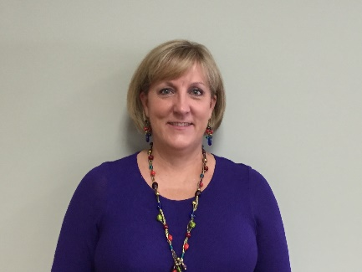

I have a Bachelor of Science in Elementary Education with a specialization in Reading. I taught first grade for 4 years, third grade for 23 years, and second grade for 3 years for a total of 30 years of teaching. I have endorsements in ESL (English as a Second Language) and GT (Gifted and Talented), and I was also an Instructional Specialist. I retired from teaching in 2015.

Melissa Johnson
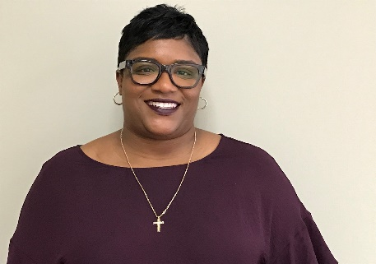

Deidra Lyons-Lewis currently serves as a high school principal
in Fort Bend ISD. She has been an educator for over 20 years
and has also served as a teacher and counselor.
Deidra is passionate about affording every child
she encounters with a great life and school experience.
Volunteering as a CASA is one of her favorite outreach activities.
Deidra Lyons- Lewis

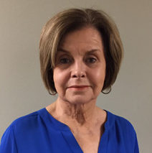
Jackie Townsend has worked in public education for over thirty years as a district special education direction, education service center special education director, educational diagnostician, special education counselor, dyslexia specialist and classroom teacher. Jackie served as the Texas Education Agency (TEA) Project Director for the Texas Behavior Support Initiative and on the TEA State Deaf Education Strategic Planning Committee. Jackie is president of JWT Consulting Services, an educational consulting company, specializing in program evaluation and continuous improvement, special education leadership, budget development and staff development.
Jackie Townsend

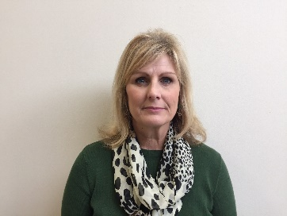
I have taught at the elementary, middle school and high school levels.
My educational positions outside of the classroom include Kindergarten
Coordinator, Language Arts Coordinator, Assistant Principal and Principal.
After retirement, I have enjoyed consulting on leadership,
emotional intelligence, and team improvement.

Sheri Walters

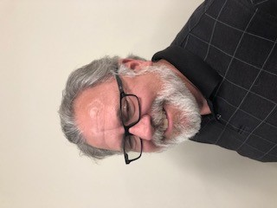
After spending a decade in construction management, I decided to go back to school and get my teaching certificate. I began my teaching career as an elementary special education teacher, teaching in-class support, and resource classes. After doing additional graduate work, I accepted an opportunity to teach students with an Autism Spectrum Disorder. This was a great opportunity to work with students with comorbidities and work in an Applied Behavioral Analysis environment. After receiving additional certifications in English and ESL, I spent the remaining eight years of co-teaching English in a Disciplinary Alternative Education Program. Besides teaching, I also wrote the social skills curriculum used by the high school.
David Barnett

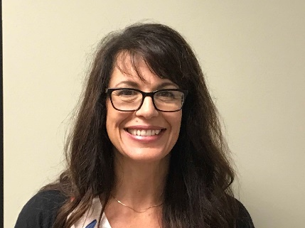
Charmaine Queiroga graduated from Texas State University
to become a Special Education Teacher. She has now been
teaching for 12 years. She has taught in HISD, FBISD and now
LCISD and is currently pursuing master’s in social work
at the University of Houston.

Charmaine Queiroga

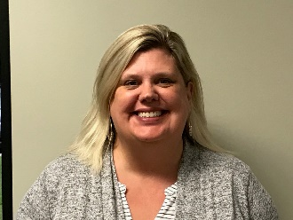

I have been in the education field for over 20 years. I’ve spent 15 of those years teaching special education focusing on kids with moderate to severe disabilities. I am currently teaching a FLaSH (Functional Living and School Health) classroom in the Fort Bend Independent School District.

Kirsten Drews

My name is Kathy Eyring and I retired after forty years in education.
This Photo by Unknown Author is licensed under CC BY
I have taught in Houston ISD, Lufkin ISD, and Alief ISD.
I am certified to teach grades one through eight.
I have additional certifications in ESL, and Reading Recovery.
I have been a classroom teacher in first, second, and third grades,
a Title One Reading Interventionist, Reading Recovery Specialist,
and Reading Interventionist. I have also been involved as a mentor
for new teachers, developing curriculum, and a member of the
Instructional Leadership team.
Kathy Eyring

I have been married for 35+ years. During that time we have lived in the Clear Lake area, West Texas, suburban Chicago and now Katy. Our 32 year-old son, Brendan is married to Katie. They live in Southern California. My working life includes: 15 years in the oil and gas field as an engineer, 20+ years as a secondary Math and Science teacher. I will be retiring from KatyISD at the end of the school year. My hobbies include knitting, reading, walking, gardening and listening to all kinds of music. We will be rescuing a puppy from an animal shelter this summer.
-Maria Scott

