Engaging Tools

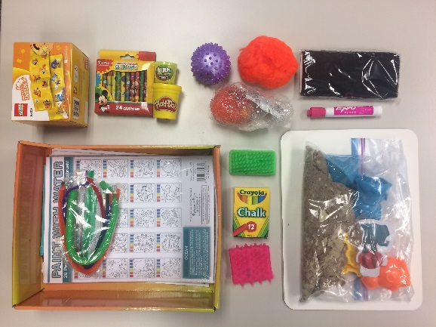

N.E.S.T. Sensory bags are ready and available to check-out and use on your next home visit! They include a variety tools to engage children who have disabilities or who might benefit from very tactile, hands on interactions. There are 6 blue bags and they are available to check out when necessary and then you can return it when it is no longer needed. Please contact April Shaver or Alli Waterwall to learn more about how to utilize this resource!