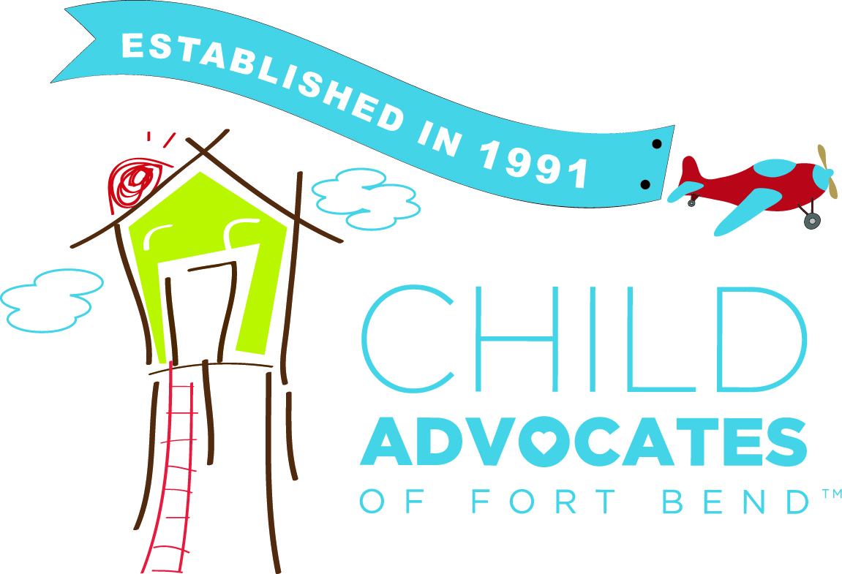
CHILD ADVOCATES OF FORT BEND
RECORDS RETENTION POLICY

All records and files of Child Advocates of Fort Bend and its constituent programs will be safely and securely maintained in the offices of Child Advocates of Fort Bend consistent with currently acceptable business practices. Destruction and/or deletion of Child Advocates of Fort Bend’s records, including those of the individual programs, will be accomplished in a manner that assures permanent and complete obliteration of the records without possible resurrection.
CHILDREN’S ADVOCACY CENTER (CAC)
The CAC will gather basic demographic information when possible regarding clients, non-offending family members and alleged perpetrators including names, dates of birth, contact information, race/ethnicity, income, marital status and insurance. Information will be gathered at the time of intake and entered into Collaborate. Clients will not be denied service if information is unable to be gathered.
The files, reports, records (including electronic records), communications, and working papers used or developed in providing services of the Children’s Advocacy Center (CAC) are the property of the CAC and are confidential pursuant to the provisions of Section 264.408, Texas Family Code. These records are subject to disclosure only as allowed by that section. No other disclosure of such records will be made unless under the order of a court of competent jurisdiction.
Electronic recordings of interviews conducted in the Center are made in duplicate originals; additional reproductions in the original form may be reproduced as needed and provided to partner agencies entitled to such interview recordings. The CAC will permanently retain all interview recordings made in the CAC on or after the date of adoption of this policy. Retention and/or destruction of any duplicate original interview recording is to be determined and accomplished pursuant to the policy of the agency in possession of such recording. Electronic recordings of interviews are not the property of the CAC but are the property of departments in accordance with TFC Sec. 264.408 (d). Any requests for electronic recordings of interviews will be referred to the District Attorney’s Office. Hard drives of all stored forensic interviews are password protected and kept in a locked filing cabinet. The Manager of Forensic Interviewing manages any requests for forensic interviews.
All records generated by the provision of mental health services by CAC personnel and interns are also confidential and shall not be disclosed to any person or agency except by order of a court of competent jurisdiction or upon execution of a proper written release by the client, parent, or legal guardian as appropriate. Such records may also be disclosed to the client (or parent/legal guardian) to whom services were given upon the client’s or guardian’s request if, in the judgment of the service provider, such disclosure would not be detrimental to the client. Mental health records of the CAC will be stored and retained indefinitely. Per the Texas Family Code, the District Attorney’s Office may receive copies of therapy recordings with a subpoena.
Any order of a court of competent jurisdiction to expunge particularly described records of the CAC supersedes these record retention policies. Records destruction will be carried out in a manner consistent with the court order.
All client related records generated by the CAC, other than electronic recordings of interviews, are to be stored and retained by the Center indefinitely.
Records generated by the provision of medical services requested by the CAC or any of its partner agencies are the property of the provider of such services and are retained pursuant to that provider’s policy.
Statewide intakes received as part of the Multi-Disciplinary Enhancement program will be retained electronically for 6 months of receipt. Reports will be flagged for destruction at the 6-month mark. Any paper statewide intakes or law enforcement reports will be destroyed within 30 days of the forensic interview. Statewide intakes are the property of DFPS.
All files are kept on site at Child Advocates of Fort Bend. Paper files are kept in locked filing cabinets in the Children’s Advocacy Center at 5403 Avenue N. Rosenberg, TX 77471 behind key card access locked doors. All electronic files containing client information are password protected and accessible to only CAC employees. Mental Health records are only accessible to mental health providers.
Upon closure of a case, all case files will be scanned into a secure archive folder on the CAC drive. The scanner and a second person will review the scanned documents to ensure scanning was complete. Once verified, the paper file will be shredded within 30 days of scanning.
CAFB employees will respond to all subpoenas prior to the listed court date by contacting the issuer of the subpoena. Records, exclusive of electronic recordings of interviews, may only be turned over with a court order signed by the judge.

COURT APPOINTED SPECIAL ADVOCATES (CASA)
The reports, records (including electronic records), working papers, and volunteer notes generated by the staff and volunteers on each case in which there is a court appointment of a special advocate constitute the case files of the CASA program. These records are confidential under provisions of the Texas Family Code and will not be disclosed except as provided by law or under force of order of a court of competent jurisdiction. Case files will be maintained until the last child involved in the case reaches his or her 18th birthday or until 21st birthday if youth is in extended care.
CASA AND CAC VOLUNTEERS
All files and records specifically relating to program volunteers are confidential under provisions of the Texas Family Code and will not be released except under force of order of a court of competent jurisdiction. These records will be maintained for five (5) years beyond completion of each volunteer’s participation in their last case, or their resignation, or their last day of service, if no resignation is given.
DEVELOPMENT
Event volunteer records and notebooks on special events will be permanently maintained at the discretion of the Marketing Specialist. Photographs will be maintained at the discretion of the Communication Specialist. Donor records, including gifts and activity will be maintained permanently in Raisers Edge. Appendix A will govern the retention of development financial records.
ADMINISTRATIVE RECORDS
Personnel
All records and files relating to the employment, tenure, compensation, discipline, commendations and promotions of each employee of Child Advocates of Fort Bend will be permanently maintained. Terminated employee files will be held for 7 years after termination of employee.
Financial
All financial records will be maintained according to the length specified in Appendix A, attached hereto and made a part hereof.
Grants
All records relating to the application for, award of, and expenditure of grant funds will be maintained pursuant to the requirements of each individual grant. In those instances where there is no record retention provision, grant records will be maintained for seven (7) years after the end of the external audit of the year of the grant’s expiration.
Correspondence will be scanned and retained for all major donors:
- proposals
- award letters/execution agreements
- rejection letters
- stewardship correspondence
- special inquires and responses

A central file will be maintained for planned gifts from individuals.
Miscellaneous
All other records generated by the day-to-day operation of Child Advocates of Fort Bend and its programs will be maintained at the discretion of the agency.

APPENDIX A
ACCOUNTING RECORDS RETENTION REQUIREMENTS

Type of Records Retention Period

Accounts Payable/Vendor Files | 7 years
Accounts Receivable | 7 years
Audit Reports & 990s | Permanently
Bank Signature Papers | 7 years after account closes
Bank Statements | 7 years
Cash Books | Permanently
Chart of Accounts | Permanently
Contract Files | 7 years after expiration of contract
Correspondence (with customers & vendors) | 2 years
Correspondence (Legal and Important matters) | Permanently
Credit Card Records | 7 years after cancellation
Deeds, mortgages, and bills of sale | Permanently
Depreciation Schedules | Permanently
Employment Applications or Resumes | 3 years
Endowment Account Summary Statements | Keep year end, destroy quarterly
Equipment Lease Records | 7 years after expiration of lease
Expense Records | 7 years
Financial Statements (Annual) | Permanently
Fixed Asset Purchases | Permanently
General Ledger | Permanently
Insurance Policies (expired) | 7 years
Insurance records, current accident reports, claims, policies, etc. | Permanently
Invoices (to customers, from vendors) | 7 years
Minute books, bylaws and charter | Permanently
Payroll Records | 7 years
Purchased Equipment Records | 7 years
Equipment Service Records | Until equipment is no longer in use
Tax Records (personnel & property) | Government guidelines
Trademark registrations and copyrights | Permanently

