November NEST Activities

November
- Education
  - Cloud in a Jar
https://www.giftofcuriosity.com/weather-science-how-to-make-a-cloud-in-a-jar/

- Social Development
  - A Tooty Ta Ta
https://www.youtube.com/watch?v=ea4TVgo_8Dk

- Health and Hygiene
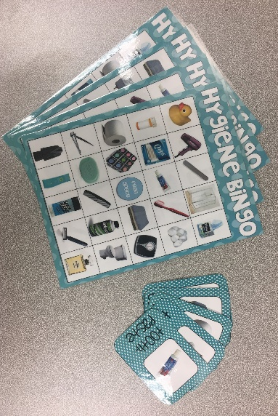
  - Hygiene Bingo (available at the CASA office)

